Question 1

a)
FPGA’s have several advantages some are:
- Ease of prototyping
- Fast prototyping
- Low cost of prototyping
- Re-programmability
- Availability of variety of FPGAs with embedded units
- Availability and friendliness of tools
- Fast testing of the circuit
b)
F(A,B,C,D,E,F,G,H) = $ABC+\overline{A}BE+BCFGH+CDFH+A\overline{C}FG$
F can be implemented with a variety of 2,3 and 4 variable LUT. In here, we give 2 implementations selected due to their lowest delay.
$$\overline{A}$$
$$\overline{D}$$
Delay |  | Area
4 |  | $$4*3LUT$$
2 |  | $$4*2LUT$$
3 |  | $$2*4LUT$$
9$ns$ |  | 124${mm}^{2}$
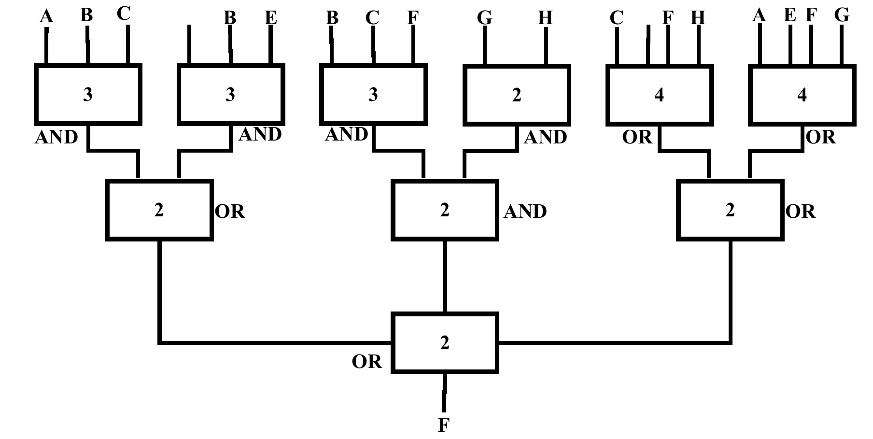
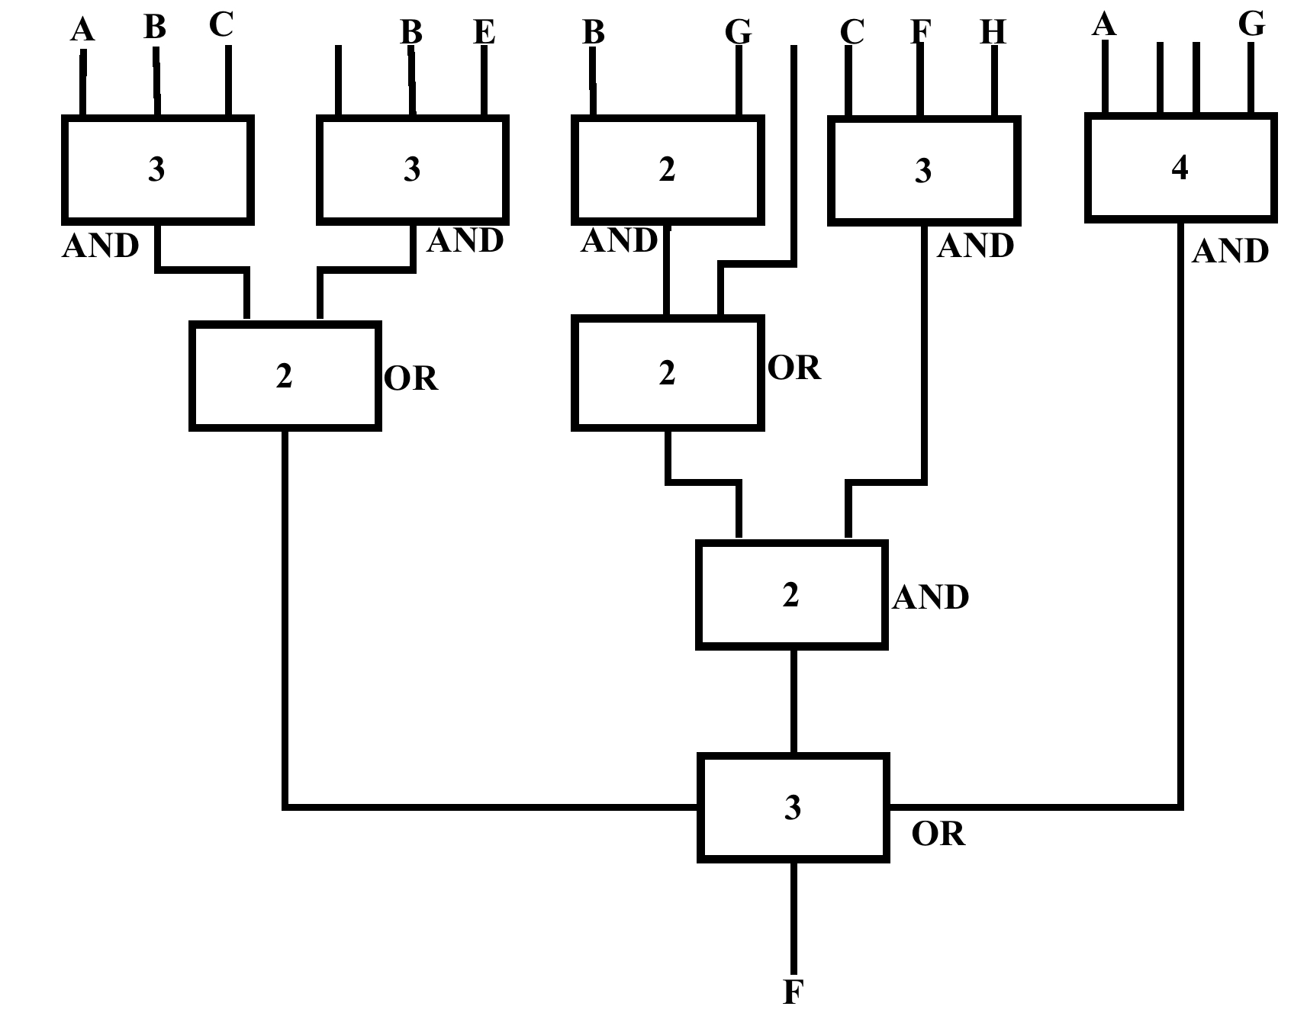
$$\overline{F}$$
$$\overline{C}$$
$$\overline{A}$$
$$\overline{D}$$
Delay |  | Area
2 |  | $$4*3LUT$$
2 |  | $$4*2LUT$$
2 |  | $$1*4LUT$$
3
9$ns$ |  | 98${mm}^{2}$

The second implementation has the same delay, but the better area.
Question 2

$$x.y-z=\left(x.y\right)+(-z)$$

${Z=Z}_{3} Z_{2} Z_{1} Z_{0}$ Z is inverted and it is added to one get its –ve value and NOT XORed since we want is –ve.

$$Z=\overline{Z_{3}{ Z}_{2 }Z_{1 }Z_{0}}$$
1+
extension …. $\overline{Z_{3}Z_{3}Z_{3}}$

$$Z_{3}$$

$Z_{3} Z_{2} Z_{1}$ $Z_{0}$

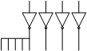
+1
$$\overline{Z_{3}}\overline{Z_{3}}\overline{Z_{3}}\overline{Z_{3}}$$

 |  |  |  |  | $$X_{3}$$ | $$X_{2}$$ | $$X_{1}$$ | $$X_{0}$$
 |  |  |  |  | $$Y_{3}$$ | $$Y_{2}$$ | $$Y_{1}$$ | $$Y_{0}$$
 |  |  |  |  | $$P_{03}$$ | $$P_{02}$$ | $$P_{01}$$ | $$P_{00}$$
 |  |  |  | $$P_{13}$$ | $$P_{12}$$ | $$P_{11}$$ | $$P_{10}$$
 |  |  | $$P_{23}$$ | $$P_{22}$$ | $$P_{21}$$ | $$P_{20}$$
 |  | $$P_{33}$$ | $$P_{32}$$ | $$P_{31}$$ | $$P_{30}$$
 | $$Z_{3}$$ | $$Z_{3}$$ | $${\overline{Z}}_{3}$$ | $${\overline{Z}}_{3}$$ | $${\overline{Z}}_{3}$$ | $${\overline{Z}}_{2}$$ | $${\overline{Z}}_{1}$$ | $${\overline{Z}}_{0}$$
 |  |  |  |  |  |  |  | 1 | $$←+1$$
$$M_{8}$$
Critical Path
H
H
H
+
H
H
+
+
+
+
+
+
+
+
+
+
+
+
+
+
+
H
$${\overline{Z}}_{3}$$
$$Z_{3}$$
$${\overline{Z}}_{3}$$
$${\overline{Z}}_{2}$$
$$M_{7}$$
$$M_{6}$$
$$M_{5}$$
$$M_{4}$$
$$M_{3}$$
$$M_{2}$$
$$M_{1}$$
$$M_{0}$$

$${\overline{Z}}_{3}$$
$$P_{33}$$
$${\overline{Z}}_{1}$$

$$P_{00}$$
$${\overline{Z}}_{0}$$
1

$$Critical Path=8τ_{F}+τ_{AND}$$

Question 3

Present State |  |  |  | Next State
$$y_{3}$$ | $$y_{2}$$ | $$y_{1}$$ | $$y_{0}$$ | $$y_{3}^{+}$$ | $$y_{2}^{+}$$ | $$y_{1}^{+}$$ | $$y_{0}^{+}$$
0 | 0 | 0 | 1 | 1 | 0 | 0 | 0 |  | $$P_{1}^{+}$$
1 | 0 | 0 | 0 | 0 | 1 | 0 | 0 |  | $$P_{2}^{+}$$
0 | 1 | 0 | 0 | 0 | 0 | 1 | 0 |  | $$P_{3}^{+}$$
0 | 0 | 1 | 0 | 0 | 0 | 0 | 1 |  | $$P_{4}^{+}$$

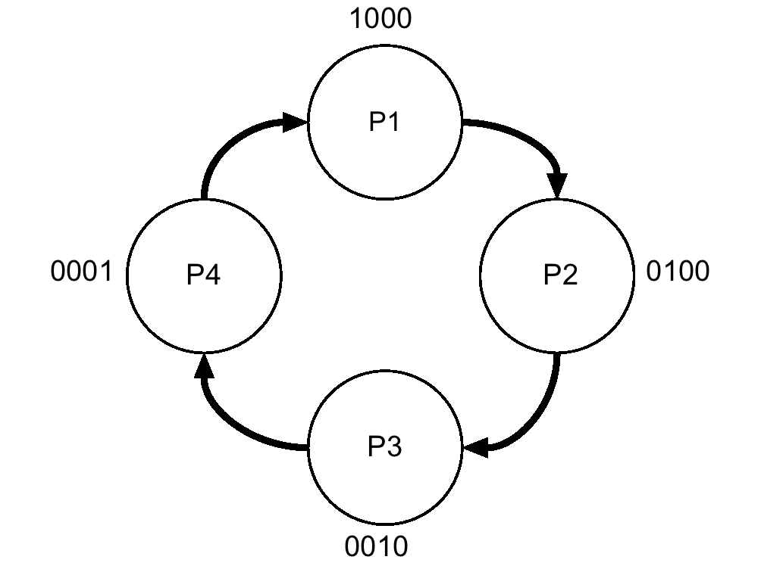

From the table above:
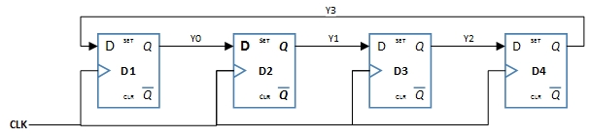
$$P_{1}^{+}=P_{2}$$ |  | $$y_{3}^{+}=y_{0}$$
$$P_{2}^{+}=P_{3}$$ |  | $$y_{2}^{+}=y_{3}$$
$$P_{3}^{+}=P_{4}$$ |  | $$y_{1}^{+}=y_{2}$$
$$P_{4}^{+}=P_{1}$$ |  | $$y_{0}^{+}=y_{1}$$

$y_{3}y_{2}$ $y_{1}y_{0}$ | 00 | 01 | 11 | 10
00 |  | 1 | X
01 |  | X | X
11 |  | X | X
10 |  | X | X

$$y_{3}^{+}=y_{0}$$

$y_{3}y_{2}$ $y_{1}y_{0}$ | 00 | 01 | 11 | 10
00
01
11 | X | X | X | X
10 | 1 | X | X | X

$$y_{2}^{+}=y_{3}$$

$y_{3}y_{2}$ $y_{1}y_{0}$ | 00 | 01 | 11 | 10
00
01 | 1 | X | X | X
11 | X | X | X | X
10

$$y_{1}^{+}=y_{2}$$

$y_{3}y_{2}$ $y_{1}y_{0}$ | 00 | 01 | 11 | 10
00 |  |  | X | 1
01 |  |  | X | X
11 |  |  | X | X
10 |  |  | X | X

$$y_{0}^{+}=y_{1}$$

Question 4

a)

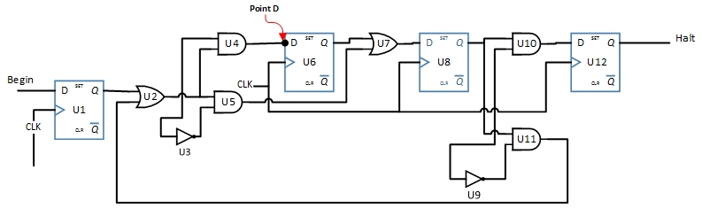

There are 6 paths:
Path1: $u_{1}-u_{2}-u_{4}-u_{6}$
Path2: $u_{6}-u_{7}-u_{8}$
Path3: $u_{8}-u_{10}-u_{12}$
Path4: $u_{1}-u_{2}-u_{5}-u_{7}-u_{8}$
Path5: $u_{8}-u_{11}-u_{2}-u_{4}-u_{6}$
Path6: $u_{8}-u_{11}-u_{2}-u_{5}-u_{7}-u_{8}←By inspection and calculation Critical path$

$$u_{5}$$
$$u_{2}$$
$$u_{11}$$
$$u_{8}$$

${CL}_{6}=0.2\left(1.5+1.5\right)+2+0.25*1.5+2.5+0.25*\left(1.5+1.5\right)+2.0+0.25*1.5+2.5+0.25*1=11.35ns$

$$u_{7}$$

$$T_{max}=3+11.35+1.5=15.85ns$$
$$S_{o}f_{max}=\frac{1}{T_{max}}=\frac{1}{15.85}=63.1MHz$$

b)
Path delay at point D, $u_{6}$ which is path 5.

$0.2\left(1.5+1.5\right)+2+0.25*1.5+2.5+0.25*\left(1.5+1.5\right)+2*0.25*1=8.47ns+3=11.47=T^{'}$

$$T_{setup slack}=\left(T_{max}-T_{su}\right)-T^{'}=15.85-1.5-11.47=0.875ns$$

$T_{hold}$ at point D, $u_{6}$ is
$$T_{h_{max}}<T_{{CQ}_{min}}+T_{{CL}_{min}}-T_{{CS}_{max}}$$

$T_{{CL}_{min}}$ is path 1 delay, $T_{{CQ}_{min}}=3$, $T_{{CS}_{max}}=0$,${CL}_{path1}=8.65$
$$∴ T_{h}=3+8.65-0=14.47$$
$$T_{h slack}=11.65-0.5=11.15ns$$

c)
When clock skew is introduced between $u_{1}$ and the rest. We calculate the changes to the path. Path 4 is the longest path.

$$T_{path4}=0.2\left(1.5\right)+2+0.25\left(1.5+1.5\right)+2+0.25*1.5+2.5+0.25*1+T_{{int}_{ff}}+T_{su}=13.175+3.5=16.67ns$$
New critical path has been introduced. This is the added delay at the input of $u_{2}$ since CLK of other FFs is taken as a reference.
$$T_{path4}>T_{path6}$$
$$New frequency=\frac{1}{16.67}=59.001 MHz$$

Question 5

a)
Typical Delays
$t_{NAND}=0.25+0.03*1.5=0.295 ns$
@ Ambient temp of 27$℃$
$$t_{XNOR}=0.4+0.05*2=0.5 ns$$
$$t_{MUX}=0.3+0.1*2=0.5 ns$$
$$t_{FF}=0.5+0.07*1.5=0.605 ns$$

Delay Variations

$k_{v}=\frac{1}{1+0.01f_{0}}=\frac{1}{1±0.01×10}=1.11$ , 0.909 voltage variation
$k_{T}=t_{a}+θ_{Ja}*P_{J}$

${\left(T_{2}\right)}_{min}=-55+30*3=35℃+273=308°K$
Junction Temp Variation
$${\left(T_{2}\right)}_{max}=125+30*3=215℃+273=488°K$$

${\left(k_{T}\right)}_{min}={\left(\frac{308}{27+273}\right)}^{1.5}=+1.05$
De-rating Temp Variation

$${\left(k_{T}\right)}_{max}={\left(\frac{488}{27+273}\right)}^{1.5}=+2.09$$

Composite De-rating factor $K^{'}=K_{v}*K_{T}$
$${K^{'}}_{min}=0.909*1.05=0.954$$
$${K^{'}}_{max}=1.11*2.09$$

Min/Max delay

$$t_{NAND}=0.281ns, 0.684 ns$$
$t_{XNOR}=0.477ns, 1.16 ns$
Min, Max Delay of the Gates used in Figure 2
$$t_{MUX}=0.477ns, 1.16 ns$$
$$t_{FF}=0.58ns, 1.4 ns$$

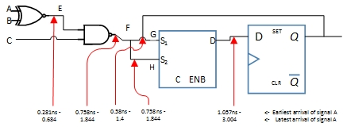

D-input
Latest arrival
$$←$$
3.004
1.057
$$t_{s}$$

b)
Total Period $T=T_{{CQ}_{max}}+T_{{CL}_{max}}+T_{{su}_{max}}-T_{{CS}_{min}}$
$$T_{max}=1.4+3.004+0.2-0=4.604ns$$
$$f=\frac{1}{T}=\frac{1}{4.604}=217 MHz$$

Question 6

a)
There are many ways of writing this piece of code. Here is just a simple example:
library IEEE;
use IEEE.std_logic_1164.all;

entity exam_circuit is
port (A, B : in std_logic;
O1,O2 : out std_logic);
end exam_circuit

architecture structural of exam_circuit is
component decoder2to4
port(a, b : in std_logic;
d1, d2, d3, d4 : out std_logic);
end component decoder2to4;

component AND_gate
port(in1, in2 : in std_logic;
out1 : out std_logic);
end component AND_gate;

component OR_gate
port(in1, in2 : in std_logic;
out1 : out std_logic);
end component OR_gate;

signal d1, d2, d3, d4 : std_logic;

begin
decoder1: decoder2to4 portmap (A, B, d1, d2, d3, d4);
AND1 : AND_gate portmap (d1, d2, O1);
OR1 : OR_gate portmap (d3,d4, O2);

End structural

b)
L2: X,Y : I std_logic
L4: end Half_A_Con
L5: H_A_Behav
L7: -signal
L8: process(X,Y)
L13: problem of conversion X,Y
L17: endif

